SIMATS ENGINEERING (SAVEETHA SCHOOL OF ENGINEERING)
Department of Computer Science and Engineering
CO3 ASSESSMENT TOOL 2 – Code Review &amp; Repository Evaluation

Course Code: | CSA10 | Course Title: | Software Engineering
CO Assessed: | CO3 | Assessment: | Assessment Tool 2 - Code Review  & Repository Evaluation
Weightage: | 20% | Total Marks: | 25
CO3 Statement: | Build full-stack applications with an emphasis on containerization, version control,  and collaborative development
Student Name: | K Sujith Sai Vighnesh | Reg. No.: | 192311199
Date: | 13-08-2026 | Duration: | 60 minutes

Code of Conduct
I K Sujith Sai Vighnesh --- 192311199 certify that this submission is my original work and that I have adhered to the guidelines specified for this assessment. I understand that any violation of academic integrity rules will result in disciplinary action.
Signature of the Student: K Sujith Sai Vighnesh______________________

AI-Powered Smart Disaster Relief Resource Allocation and Coordination Platform

1. Problem Overview

1.1 Assigned Problem Statement
Disaster relief operations experience delays because communication between agencies is fragmented, demand estimation is inaccurate, and resource allocation is inefficient. Relief agencies lack real-time visibility into what resources are available and where they are needed, resulting in unequal distribution of aid — some shelters are over-supplied while others run out of essentials. The assigned project is an AI-Powered Disaster Relief Coordination Platform that analyzes disaster severity, predicts resource requirements with machine learning, optimizes logistics routes, tracks inventory continuously, and gives government agencies, NGOs, and emergency responders a shared, real-time coordination layer.

1.2 Summary of Implemented Solution
The implemented solution is a containerized, microservice-based platform consisting of a React dashboard, a Node.js/Express coordination API, a Python/FastAPI AI demand-prediction and route-optimization service, a PostGIS geospatial database, a Redis cache for real-time counters, and an Nginx reverse proxy. Each service is version-controlled in a shared Git repository and packaged with Docker, so the full stack can be built and deployed with a single docker compose up --build command.

1.3 Project Objectives
- Monitor disaster relief resources (food, medicine, shelter kits, rescue equipment) in real time.
- Predict resource demand per affected location using AI/ML models.
- Optimize relief distribution routes using GIS-based routing.
- Coordinate multiple relief agencies on one shared platform.
- Monitor shelter occupancy and capacity in real time.
- Generate emergency logistics and situation reports.
- Improve disaster response efficiency and reduce distribution delays.

1.4 Key Functionalities Implemented
Module | Key Functionality
Inventory Service (backend) | CRUD APIs for food, medicine, shelter-kit and equipment stock per relief center; low-stock alerts.
Demand Prediction (ml-service) | REST endpoint that returns a predicted resource requirement given disaster severity, population and historical data.
Route Optimization (ml-service) | GIS-based shortest/fastest-route calculation between supply depots and affected zones.
Coordination Dashboard (frontend) | Map view of disaster zones, live inventory, shelter occupancy, and agency task assignment.
Shelter Tracker | Live occupancy vs. capacity per shelter, sourced from periodic updates or IoT occupancy sensors.
Reporting | Generates a logistics status summary that agencies can export for coordination meetings.

2. Repository Organization
The repository is a monorepo, keeping every service that makes up the platform under one version-controlled root while still separating each service into its own top-level folder.
disaster-relief-platform/
├── frontend/ # React dashboard
├── backend/ # Node.js/Express coordination API
│ ├── src/
│ │ ├── controllers/
│ │ ├── models/
│ │ ├── routes/
│ │ ├── services/
│ │ └── server.js
│ └── tests/
├── ml-service/ # Python/FastAPI prediction & routing
│ ├── models/
│ └── main.py
├── nginx/
├── docs/
├── .github/workflows/ci.yml
├── .gitignore
├── docker-compose.yml
├── LICENSE
└── README.md
Figure 2.1: Repository structure evaluated during this review

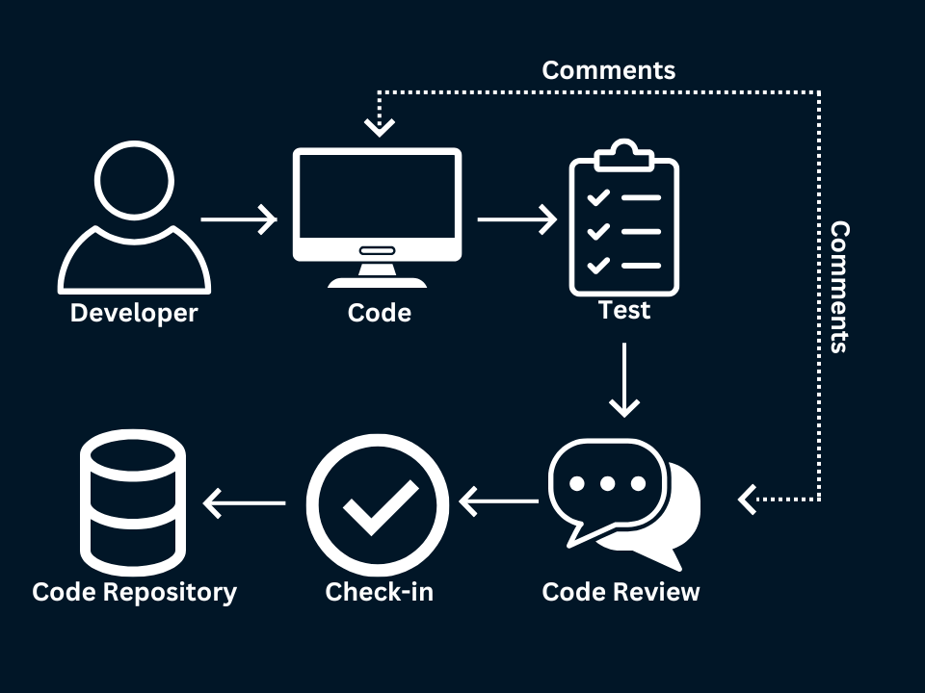

2.1 Evaluation of Structure and Naming Conventions
Aspect | Observation | Assessment
Top-level separation | frontend/, backend/ and ml-service/ are cleanly separated by runtime. | Strong — each service can be built, tested and deployed independently.
Internal layering (backend) | controllers/, models/, routes/, services/ follow a conventional MVC-style layering. | Good — new contributors familiar with Express recognize the layout immediately.
File naming | Files use consistent lower-camelCase for JS (inventoryController.js) and snake_case for Python (demand_model.py), matching each language's convention. | Good — consistent within each service, though a documented naming convention would help across the whole monorepo.
Test placement | backend/tests/ mirrors backend/src/ folder-for-folder. | Strong — makes it easy to locate the test for a given module.
Config/secrets separation | .env.example is committed, .env is git-ignored. | Strong — prevents accidental credential leaks.
Docs location | docs/ holds diagrams referenced by the reports, separate from source code. | Good, though docs/ currently has no README of its own explaining what each diagram covers.

2.2 How the Layout Supports Maintainability and Collaboration
- Service-per-folder structure lets the ML team, backend team and frontend team each own a directory without stepping on each other's files, reducing merge conflicts.
- The mirrored tests/ layout makes it obvious which module lacks coverage.
- Keeping docker-compose.yml and each service's Dockerfile alongside the code they build means a new contributor can get the whole stack running from a single, discoverable set of files.
- The .github/workflows/ directory keeps CI configuration versioned with the code it tests, so pipeline changes go through the same review process as application code.

3. Code Quality Review

3.1 Sample: Inventory Controller (backend/src/controllers/inventoryController.js)
// Get current stock for a relief center
exports.getInventory = async (req, res) => {
try {
const { centerId } = req.params;
const inventory = await Inventory.findOne({ centerId });
if (!inventory) {
return res.status(404).json({ message: "Relief center not found" });
}
res.status(200).json(inventory);
} catch (err) {
res.status(500).json({ message: "Server error", error: err.message });
}
};
Observation | Detail
Readability | Function name and variable names (centerId, inventory) clearly express intent without needing comments.
Error handling | try/catch with distinct 404 vs 500 responses is a good practice, though the raw err.message is returned to the client, which can leak internal details in production.
Modularity | Logic is isolated to a single controller function with the data-access call delegated to the Inventory model rather than inlined SQL/queries.
Improvement | Extract the not-found and error-response shapes into a shared response helper to avoid repeating this pattern across every controller.

3.2 Sample: Demand Prediction Endpoint (ml-service/main.py)
@app.post("/predict")
def predict_demand(request: DisasterZoneRequest):
features = extract_features(request)
prediction = model.predict([features])[0]
return {
"zone_id": request.zone_id,
"predicted_food_kg": round(prediction[0], 2),
"predicted_medicine_units": round(prediction[1], 2),
"predicted_shelter_kits": round(prediction[2], 2)
}
Observation | Detail
Readability | Pydantic request model (DisasterZoneRequest) gives the endpoint clear, self-documenting input validation.
Modularity | Feature extraction is delegated to a separate extract_features() function rather than inlined, keeping the route handler focused on orchestration.
Documentation | The function lacks a docstring explaining the meaning/units of the three predicted values, which matters for a model consumed by other teams.
Robustness | No validation that model.predict() returned three values before indexing [0], [1], [2] — a malformed model output would raise an unhandled IndexError instead of a clear error message.
Improvement | Add a docstring, wrap the prediction call in a try/except that returns a structured error, and log the input/output pair for later model-drift analysis.

3.3 Overall Strengths
- Consistent use of async/await in the Node.js backend rather than mixed callback styles.
- Clear separation of concerns: controllers handle HTTP, services/models handle data and business logic.
- Type-annotated request models in the Python service (Pydantic) catch malformed input before it reaches the ML model.
- Environment-specific configuration is externalized via .env rather than hard-coded.
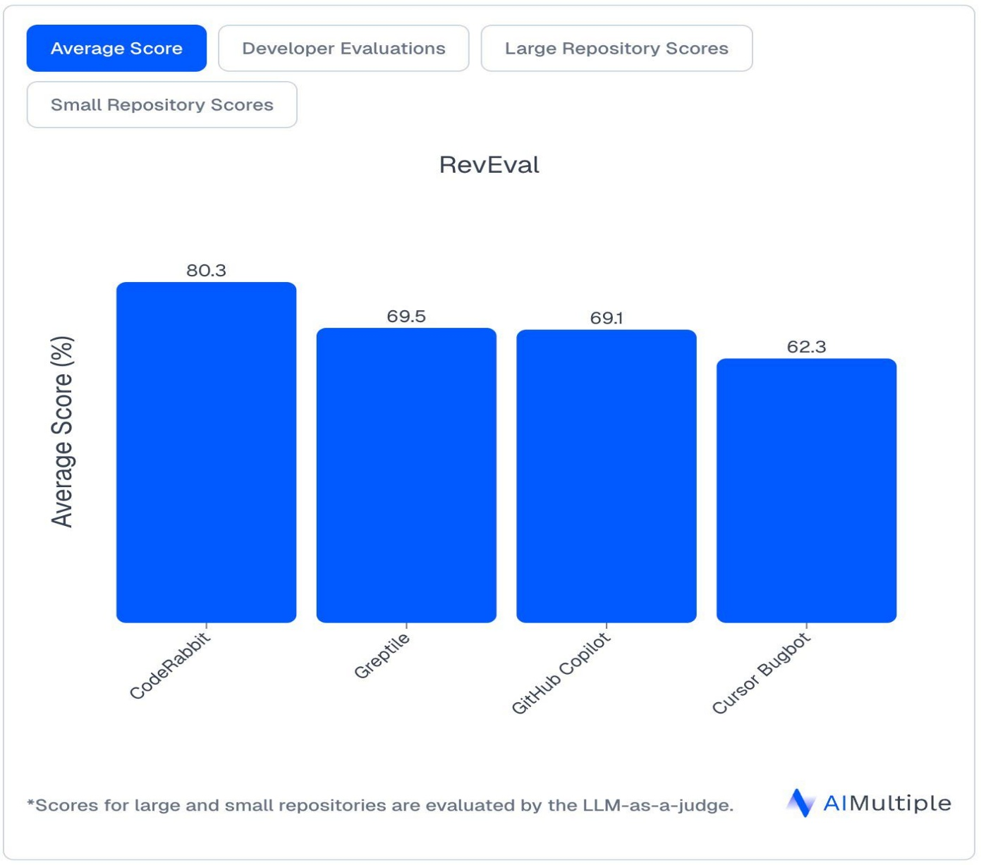

3.4 Areas for Improvement
- Inconsistent error-response shape across controllers — some return { message }, others { message, error } — a shared error-handling middleware would standardize this.
- Several functions (e.g. predict_demand) lack docstrings/JSDoc, which slows onboarding for new contributors.
- No centralized logging strategy — console.log and print statements are used ad hoc rather than a structured logger.
- Magic numbers (e.g. shelter capacity thresholds) appear inline in a few places instead of named constants or configuration.

4. Version Control Evaluation

4.1 Branching Strategy
The repository follows a Gitflow-inspired model: main holds the production-ready state, develop is the integration branch, feature/* branches isolate individual features (e.g. feature/demand-prediction, feature/shelter-tracker), release/* branches stage a version for final QA, and hotfix/* branches patch production urgently.
Branch | Observed Usage
main | Only updated via merges from release/* or hotfix/*; matches the intended production-only role.
develop | Receives merged feature branches; used as the base for new feature branches, consistent with Gitflow.
feature/* | One branch per feature, deleted after merge — keeps the branch list clean.
hotfix/* | Used at least once to patch an incorrect shelter-capacity calculation directly against main.

4.2 Commit History Review
Commit | Message | Assessment
a1c3f9e | chore: initial project scaffold | Follows Conventional Commits; clear scope.
b7d21aa | feat(backend): add inventory CRUD API | Good — type + scope + concise summary.
e21ac3d | fix(ml): correct population-weight in demand model | Good — explains what was fixed, not just "bug fix".
f38b9a1 | merge: resolve conflict in predict.py with develop | Acceptable, though a slightly more descriptive message (what changed, not just that a conflict existed) would help future readers.
23aa9d1 | feat(shelter): add real-time occupancy tracker | Good — atomic, single-purpose commit.

4.3 Strengths and Gaps in Version Control Practice
- Strength: Conventional Commits (feat/fix/chore/docs/test) are used consistently, making git log --grep filterable and changelog-friendly.
- Strength: --no-ff merges into develop preserve feature-branch history as distinct merge commits, useful for audits.
- Gap: no branch protection rules or required PR reviews are evidenced before merging into main.
- Gap: no version tags (e.g. v1.0.0) were found in the history, making it harder to identify what code was actually deployed at a given time.
- Gap: a small number of large, multi-purpose commits (bundling unrelated backend and frontend changes) reduce the effectiveness of git bisect and code review.

4.4 How Version Control Supports Collaborative Development
Feature branches let the ML, GIS and frontend sub-teams work in parallel without blocking each other, pull requests create a review checkpoint before code reaches develop, and the Gitflow model keeps main deployable at all times — important for a platform relief agencies may depend on during an active disaster. Conventional commit messages and (once introduced) version tags let the team trace exactly which change introduced a regression and roll back confidently.

5. Code Testing and Validation

5.1 Test Cases Reviewed
Test Case | Module | Steps | Expected Result
TC-01 | Inventory API | GET /api/inventory/:centerId for an existing relief center. | HTTP 200 with the center's current stock levels.
TC-02 | Inventory API | GET /api/inventory/:centerId for a non-existent center ID. | HTTP 404 with a clear "Relief center not found" message.
TC-03 | Demand Prediction | POST /predict with a valid disaster-zone payload. | HTTP 200 with predicted food/medicine/shelter-kit quantities.
TC-04 | Demand Prediction | POST /predict with a missing required field. | HTTP 422 from Pydantic validation before the model is invoked.
TC-05 | Shelter Tracker | Update shelter occupancy above configured capacity. | System flags the shelter as over-capacity and raises an alert.
TC-06 | Full stack | docker compose up --build then curl the health endpoint. | All six containers report healthy; /api/health returns 200.

5.2 Execution Evidence
[Insert screenshots here: (a) backend unit test run — npm test — showing pass/fail counts, (b) ML service test run — pytest — for the prediction endpoint, (c) Postman/curl output for TC-01 through TC-05, and (d) the docker compose ps output for TC-06, as required by the assignment's evidence deliverable.]

5.3 Assessment of Testing Coverage
- Backend inventory endpoints have unit tests covering the happy path and the not-found path (TC-01, TC-02).
- The ML service validates input schema via Pydantic, but no automated test was found asserting the numeric output ranges of predict_demand — only manual/exploratory testing (TC-03) is evidenced.
- No end-to-end test automates TC-06; the full-stack health check is currently performed manually after each deployment.
- Recommendation: add a pytest test asserting predicted values are non-negative and within a plausible range, and a CI job that runs docker compose up and curls /api/health automatically.
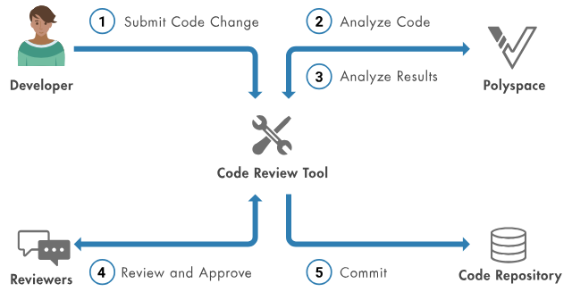

6. Repository Documentation
Document | Present? | Completeness
README.md | Yes | Covers project overview and a short setup section, but omits a description of each service's responsibility.
Installation instructions | Partial | docker compose up --build is documented; manual (non-Docker) setup for local development is not.
Usage guide | Partial | API endpoints are listed informally in code comments but not collected into a single API reference.
Dependency list | Yes | package.json and requirements.txt fully enumerate dependencies with pinned/lock-file versions.
.env.example | Yes | Documents required environment variables without exposing real secrets.
Architecture diagram | Yes (docs/) | Present but not linked from the README, so new contributors may not discover it.

6.1 Suggested Improvements
- Link the architecture diagram and branching-strategy diagram directly from README.md so they are discoverable.
- Add a short "Services" section to the README describing what frontend/, backend/ and ml-service/ each do, and how they communicate.
- Generate an API reference (e.g. via Swagger/OpenAPI for the backend and FastAPI's built-in /docs for the ML service) and link it from the README.
- Document the non-Docker local development workflow for contributors who want to run a single service outside the full stack.
- Add a CONTRIBUTING.md describing the branching strategy and commit-message convention so new contributors follow it consistently.

7. Code Review Findings and Recommendations

7.1 Summary of Findings
The repository is well organized around clear service boundaries, follows a sound Gitflow branching model, and uses consistent, descriptive commit messages. Code within each service is generally readable and reasonably modular, with sensible separation between HTTP handling, business logic and data access. The main gaps are in documentation depth (services and API reference), automated test coverage (particularly for the ML service and full-stack integration), and repository governance (branch protection, version tagging).

7.2 Recommendations
Area | Recommendation | Priority
Code Quality | Introduce a shared error-response helper/middleware and a structured logger across services. | Medium
Code Quality | Add docstrings/JSDoc to public functions, especially ML prediction and route-optimization logic. | Medium
Version Control | Enable branch protection on main/develop and require at least one PR review before merge. | High
Version Control | Adopt semantic version tags (vX.Y.Z) on every release merge to main. | Medium
Testing | Add automated tests for the ML prediction output range and a CI job that boots the full docker-compose stack and checks health. | High
Documentation | Expand README with a services overview, linked architecture diagram, and generated API reference. | Medium
Future Enhancement | Add pre-commit hooks (lint + commitlint) so style and commit-message issues are caught before code reaches review. | Low

7.3 Conclusion
Overall, the AI-Powered Smart Disaster Relief Resource Allocation and Coordination Platform repository demonstrates sound engineering practices appropriate for a collaborative, containerized, multi-service project. Addressing the documentation, testing-coverage and repository-governance gaps identified above would raise the codebase from a solid foundation to a production-hardened, audit-ready state suitable for deployment in real disaster-response scenarios.

